Name ________________________________
Date _____________________ Pd ________

The Middle Ages: Feudalism & the Manorial System

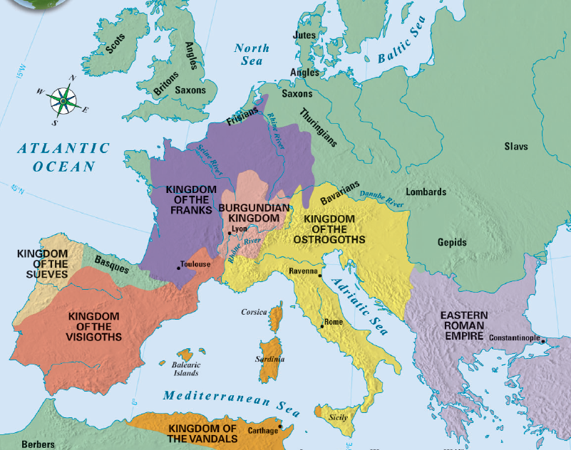
I. The Middle Ages: Western Europe after the fall of Rome
A. In the East, the Byzantine Empire became a center for ___________ & ___________________________ culture
B. In the West, Europe grew _____________ & fell into the _______________________________ from 500 to 1300 (Also known as the “_________ Ages” or “Medieval” era)
1. When barbarian kingdoms that conquered Rome, Europe was plagued by constant _________________
a. Warfare disrupted ________________, destroyed Europe’s _________________, & forced people to rural areas
b. Learning declined; Few people could __________ or _____________
c. Greco-Roman culture was ____________________
d. Europe lost a common ______________________; Latin _________________ with local languages to form Spanish, French, Italian
2. Without the __________ of the Roman Empire, Europe became divided into a series of _______________ kingdoms
a. Germanic people lived in small communities led by ______________ & his loyal warriors
b. ______________________________ & loyalty were more important than citizenship
3. The Spread of Christianity during the Middle Ages
a. During the early Middle Ages, the Germanic kingdoms were slowly converted to ___________________________
b. The Catholic ______________ became involved in ____________________ (non-religious) issues like road repair, aiding the poor, & helping _____________________________________________ expand their power
4. The _____________________ were the largest & most powerful of the Germanic kingdoms in the early Middle Ages
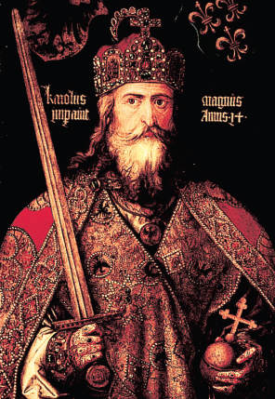
a. Frankish kings allied with the _________________________________________ & expanded their power
b. In 771, __________________________________________ (“Charles the Great”) became _______________ of the Franks
c. Charlemagne was the greatest Medieval king because he did something no other king was able to do…create an organized _______________
i. Charlemagne _________________________________ the Frankish empire
ii. He spread ___________________________________
iii. He created schools to train future _____________________
iv. He valued learning & built _______________________ in his empire
d. After Charlemagne’s death in 814, his Frankish Empire was __________________ & lost power…This was the last opportunity to provide ____________________ in medieval Europe
5. From 800 to 1000, a 2nd major wave of ____________________ struck Europe led by Vikings, Muslims, & Magyars (The 1st wave were the barbarians that attacked Rome)
a. These invasions caused widespread ____________ & suffering
b. Kings could not __________________ against invasion…People stopped looking to _____________ for protection
II. Feudalism & the Manorial System
A. ______________________ began in Europe as a way to offer ______________________:
1. Feudalism is based on land & loyalty
2. Land-owning lords offered land (called a _____________) to ____________________ in exchange for their loyalty & promise to __________________________ the lord’s land
3. Feudal society
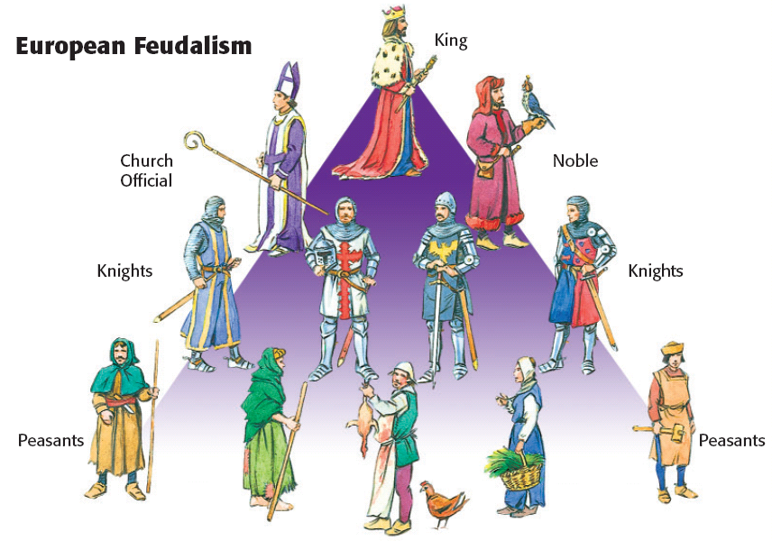
- Kings (Monarchs)

- Lords (Nobles)

- Knights

- Peasants & Serfs

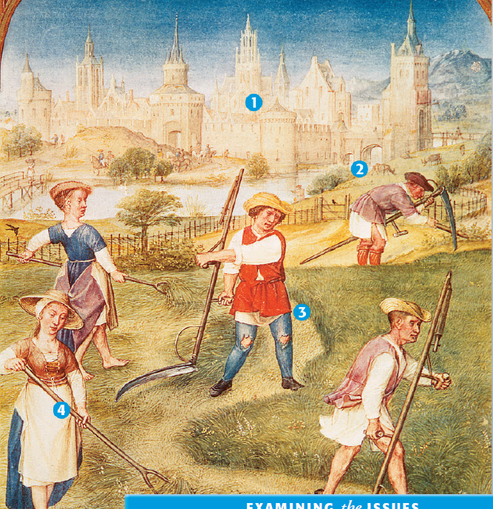
4. Lords built ___________________________ to protect their territory from outside invasions
B. During the Middle Ages, the __________________________ system was the way in which people survived
1. The lord’s ______________ was called a ______________
2. The lord provided _____________________ with housing, ___________________________, & protection
3. In exchange, peasants ___________________ the lord by working his land & providing a portion of the __________ they produced
4. Manors were ____________________________________ communities; Everything that was _______________ was produced on the manor
5. Peasant life was hard: They paid ____________ to use the lord’s mill, had to get permission to get ______________, & life expectancy was about ________ years old

