Name _________________________________
Date ______________________ Pd ________

Japanese Feudalism & Unification

I. The Early Development of Japan
A. The Geography of Japan
1. Japan is a series of ____________________________ off the coasts of ______________________________ & China
2. Like ______________________, Japan was divided by ___________________________ & had few areas for farming
3. Before 400 A.D., Japan was not a __________________ nation but was ruled by hundreds of different family _______________
4. Japan’s island location provided ______________________________ from Chinese & _________________________ invasions… but Japan was close enough to _________________________ cultural ideas from _____________________
B. Japan’s ______________________________ gave rise to a unique Japanese culture, most specifically the Shinto religion
1. ___________________ is a polytheistic religion based on the respect of _____________________________ & ancestor worship
2. Shinto worshipers believed in ___________________________________________ called ________________ that live in nature
3. The most important of the Shinto gods is the _____________________________________________ who gave light to the world
C. As Japan had more contact with Asia, it adopted ________________________ culture & ideas
1. Japan adopted the Chinese idea of an ____________________________ & rule by _____________________________________; The first Japanese emperor was said to have ____________________________ from the sun goddess
a. Japan tried, but _________________, to model the Chinese ______________________________________ for gov’t officials
b. Unlike China, Japanese emperors often did not have ____________________ over clan leaders; Japan often had an emperor _________________________________ & a clan ruler with true power
2. Japan adopted _______________________________________________ & blended Chinese styles of writing, architecture, & art
3. In the mid-700s _______________________________ was introduced in Japan from China & Korea
a. Buddhism was accepted by Japanese emperors, but in Japanese society, Buddhism & Shinto __________________________
b. An example of religious blending was ___________________________________________
D. From 794-1185, Japan entered a classical era during the ___________________ Period
1. During this time, the imperial gov’t was _________________ & Japan experienced an era of _________________ and prosperity
2. Japan developed a “_______________________________________” in poetry, art, & literature
II. Japanese Feudalism
A. By the mid-1000s, the imperial gov’t grew weak, regional __________________________________________ gained power, & Japan became _______________________________ & dangerous
1. ____________________________ attacked farmers & _____________________ attacked the coast
2. Rival clans ___________________________ for power & threw Japan into a series of __________________________________
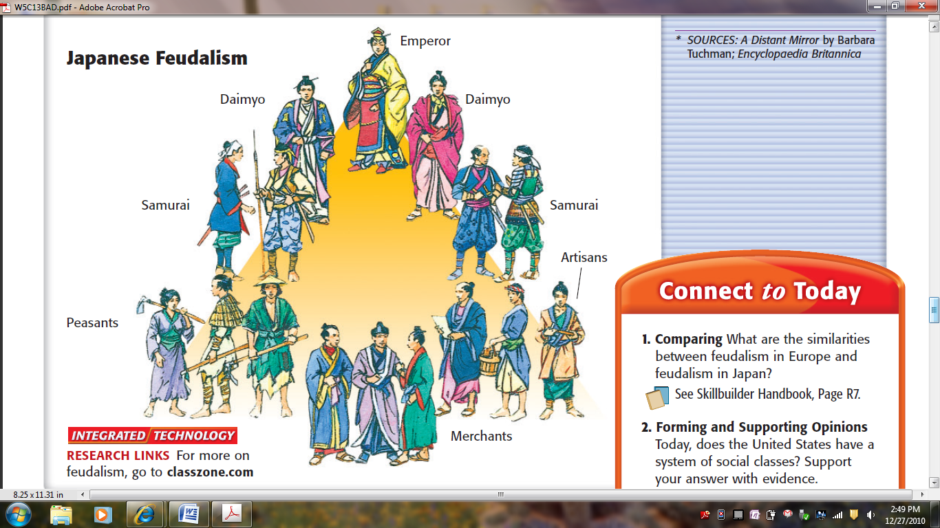
B. As a result, Japan developed a ___________________ system
1. Farmers traded land to strong ______________________ called _____________________ who offered protection
2. Daimyo were served by loyal _______________________ called ________________________
3. The emperor had ________________________________
4. Samurai warriors were usually ___________________ or dependents of daimyo, although some were _________ warriors called Ronin
a. Samurai warriors lived by a code of ______________ which demanded courage, ____________________, deity, fairness, & ____________________
b. Samurai were skilled __________________________, but also used horses & _______________ (after the arrival of Europeans)
5. In 1192, the first _____________________________ was named by the emperor
a. The emperor remained in place, but the shogun held real power & ruled as ____________________________________________
b. Shoguns’ power varied over time, but the pattern of gov’t controlled by a shogun lasted until ________________________
III. The Three Unifiers of Japan
A. From 1560 to 1600 , three powerful daimyo, known as the ________________________________________, began to restore order & ______________________ Japan
1. Oda Nobunaga
a. In 1568, a ____________________ daimyo named __________________________________________________ conquered the Japanese capital of Kyoto
b. Oda seized power by ________________________, was the first to use ______________ effectively, & eliminated Buddhist rivals that refused to accept rule by the emperor
c. By the time of his death in 1582, Japan was _____________ unified
2. Toyotomi Hideyoshi
a. Oda Nobunaga’s best general was ______________________________________________ who took over after Oda’s death
b. Toyotomi was resourceful & not ruthless like Oda; He used ____________________________________________________, adoption, & marriage to gain power over the daimyo
c. By 1590, Toyotomi Hideyoshi controlled __________________ of Japan & tried unsuccessfully to conquer _______________
3. Tokugawa Ieyasu
a. After Toyotomi ‘s death in 1598, one of his daimyo allies named _______________________________________ completed the ____________________________ of Japan in 1600
b. In 1603, Tokugawa became _________________________ of Japan, moved to capital to Edo (later called Tokyo), & restored gov’t & order to Japan
c. Tokugawa ruled until 1615, but he created a line of ________________________ called the Tokugawa Shogunate that ruled Japan until 1867
B. The Tokugawa Shogunate
1. For more than 250 years, Tokugawa’s successors ruled Japan as shoguns
a. During this time, Japan benefited from _______________; The ___________________ boomed & became more commercial
b. European __________________________ & __________________________ first arrived in Japan in the mid-1500s
c. Tokugawa enjoyed _________________ with Europeans & was fascinated to _____________________ about their military, new technologies, & ideas
2. Christian Missionaries & Merchants
a. Between1549 & 1600, European missionaries had converted _______________________________ Japanese to Christianity
b. This __________________ Tokugawa because the missionaries _______________________ Japanese cultural beliefs & laws
i. In 1612, Tokugawa ___________________ Christianity & began ruthlessly _____________________________ Christians
ii. All Japanese were forced to be faithful to _________________________
C. Japanese Isolationism
1. Tokugawa shoguns decided to ________________________ foreign merchants & missionaries
2. By 1639, Japan adopted a “____________________________________________________” & ended almost all foreign contacts
3. One Japanese port at ____________________________ in Nagasaki Bay remained open but only to Dutch & Chinese merchants
a. Japanese ________________________ remained in place for over _____________ years until the 1850s
b. During this era of isolation, Japan had profitable ______________________, became self-sufficient, limited foreign ideas, & reduced Europe’s ability to _______________________ Japan
Japanese Feudalism European Feudalism

Who was the best emperor? Name ___________________________________

Directions: Complete the chart below, rank order the emperors, and then begin a dialogue. Pass your paper to another student who will complete the next comment, etc.

Suleyman the Magnificent |  | Kangxi
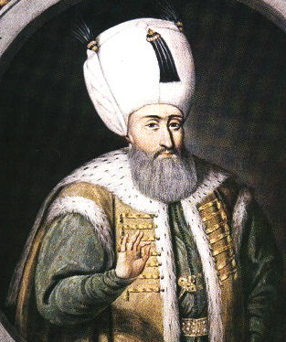 | 1. Where did he rule?  2. What were his greatest accomplishments?  Rank Order: | 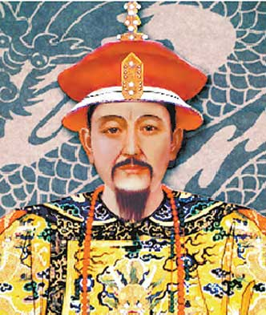 | 1. Where did he rule?  2. What were his greatest accomplishments?  Rank Order:
Shah Abbas |  | Oda Nobunaga
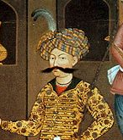 | 1. Where did he rule?  2. What were his greatest accomplishments?  Rank Order: | 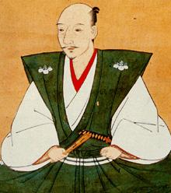 | 1. Where did he rule?  2. What were his greatest accomplishments?  Rank Order:
Akbar |  | Tokugawa Ieyasu
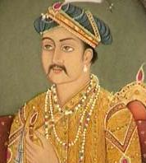 | 1. Where did he rule?  2. What were his greatest accomplishments?  Rank Order: | 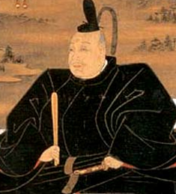 | 1. Where did he rule?  2. What were his greatest accomplishments?  Rank Order:
Comment 1: Who was the best leader and why?

Name ____________________________________________

Comment 2: I agree, he also….

Name ____________________________________________

Comment 3: I disagree because….

Name ____________________________________________

Comment 4: Don’t forget about….

Name ____________________________________________

Comment 5: I agree, he also….

Name ____________________________________________

Comment 6: I disagree because….

Name ____________________________________________

